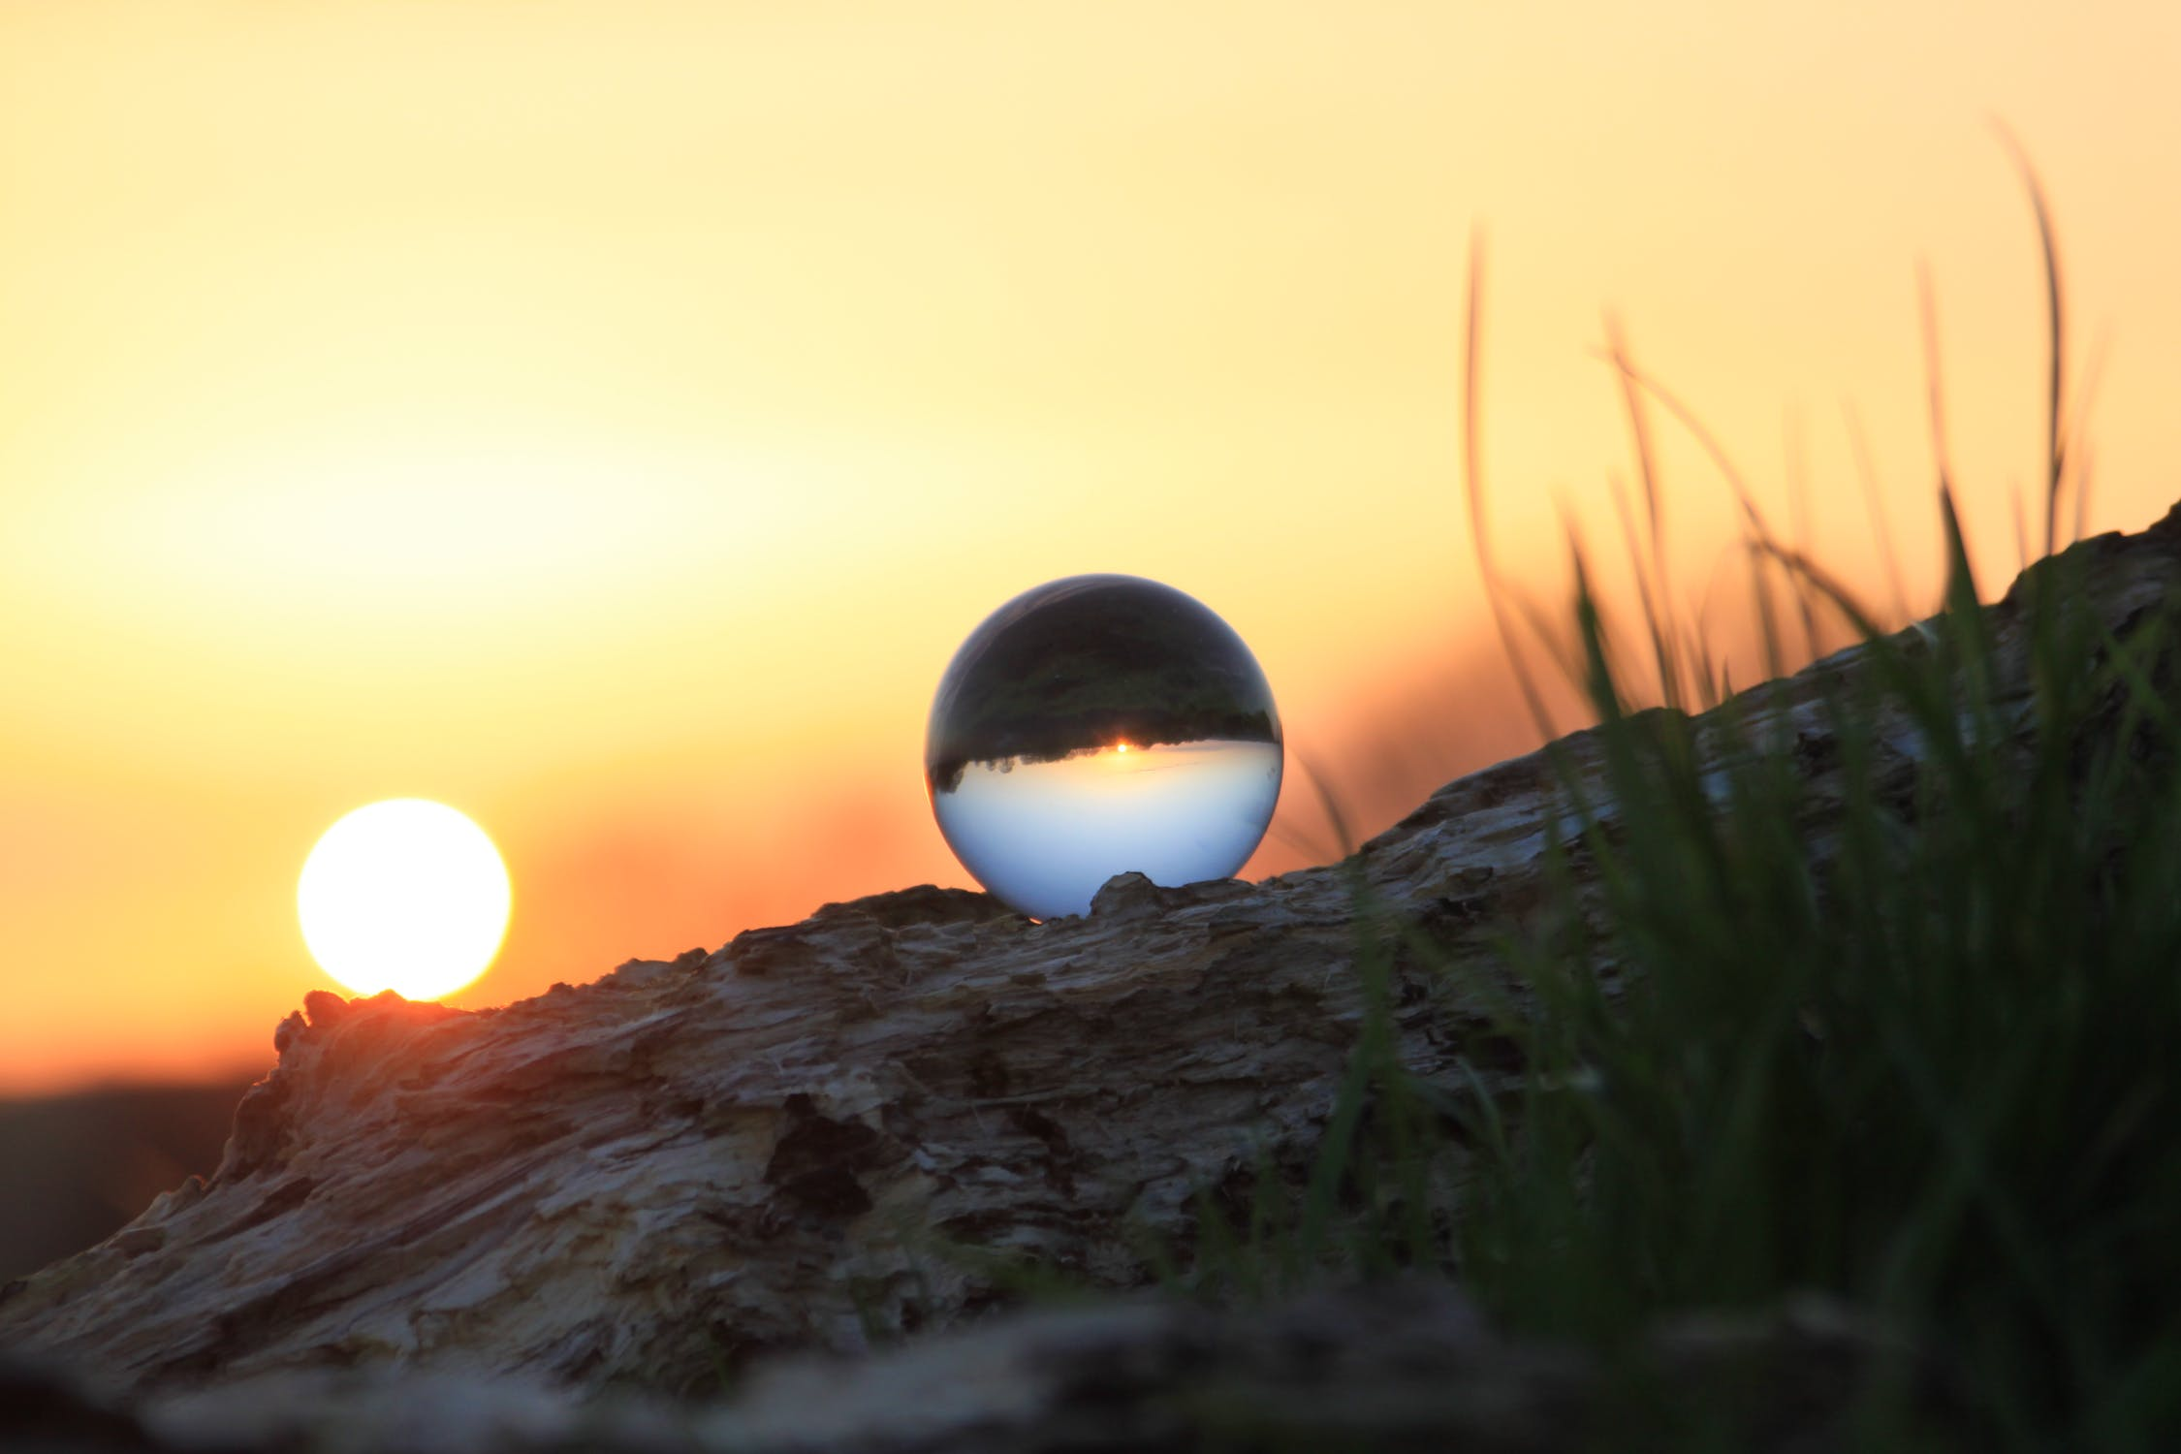
Image via Pexels

Pandemic Stress Management Made Possible Through Meditation

The coronavirus outbreak has had a significant effect on everyone. Even if you haven’t been directly touched by the virus, the stress of unprecedented disruption of daily life is likely to have consequences on even the most well-balanced individual. There are ways of coping, though, and one of the most accessible and beneficial is meditation. With that in mind, let’s explore the following advice brought to you courtesy of Lift OneSelf.

Benefitting From Meditation
Even if you never meditated before, you can easily learn. It requires no fancy equipment or prior knowledge, and there is plenty of reason to believe that starting now could help you manage the stress of the pandemic and life in general.

Meditation can have a big impact on your emotional well-being. By making time to focus inward, you are taking back control of your time and energy, and training your mind to respond with better control to outside stressors. Those who practice meditation feel calmer afterward as tension leaves their body and their minds are clearer. They may also experience prolonged emotional benefits such as being able to handle stressful situations better and becoming more self-aware.

There are also physical benefits to meditation. PositivePsychology explains that routine meditation boosts the body’s immune system and stabilizes blood circulation. It can also help with pain management as an alternative to or working in conjunction with opiates.

You can enjoy even more benefits by adding yoga to the mix. With the physical component yoga brings, you might find yourself even more relaxed, more flexible, physically stronger, and more emotionally resilient.

Setting Up Your Space
Set yourself and your meditation practice up for success by creating a peaceful place in your home. Choose an area where you will have room to practice and the privacy you need to do so. Don’t feel limited by a lack of space. Focus on what you can do with the space you have to make your meditation practice feel light and serene.

Be sure to clean and declutter first as too much stuff can add to mental and physical stress. Consider decorating it simply but brightly to infuse your practice with positivity. Let in some fresh air and sunlight if you can, and take steps to eliminate foul vibes. This could come from stale belongings or stale attitudes; the key is to bring in as much positivity as possible.

Getting Started
Now that your space is ready, you can begin your practice. For your session, you will need to make sure your space is quiet and that you will not be interrupted. Next, sit down in a position that is comfortable to you. This can be in a chair, on the floor, on a yoga mat, or whatever else suits you. Close your eyes and focus inward. Begin breathing carefully, inhaling and exhaling with intention and ease. Try to clear your mind and be present in the moment as you continue breathing deliberately throughout the rest of your session.

It can be very helpful to have a guide while meditating, especially when you are first starting out. Check out pre-recorded sessions available online that are narrated by experienced guides. There are a variety available for different moods and situations so you can find the right one for you. You can even engage the services of a personal, professional guide over video call to help lead your practice.

Don’t feel discouraged if you can only meditate for a short period at first. You can lengthen your sessions over time. Though many of those who practice meditation spend thirty or more minutes meditating during a session, many people experience benefits from as few as five to ten minutes of meditation a day.

This crisis has been difficult for everyone, and the toll on your mental and physical health may be overwhelming at times. It doesn’t have to remain that way, though. With the right practice and guidance, you can recenter yourself, learn how to work through your stress, and reclaim your inner peace.

Connect with Lift OneSelf for more information and inspiration for balancing your day-to-day life.

